Michael Dell

CEO and Chairman at Dell Technologies

Summary

I started Dell with $1000 in my freshman dorm room at the University of Texas.

Experience

Board Member at Pivotal, Inc.

September 2016 - Present

Chairman at SecureWorks

April 2011 - Present

Chairman and CEO at Dell Technologies

July 2016 - Present

www.delltechnologies.com

Chairman at VMware

September 2016 - Present

http://ir.vmware.com/overview/governance/board-of-directors/default.aspx

Co Founder at Michael & Susan Dell Foundation

1999 - Present

Founder at MSD Capital

1998 - Present

http://www.msdcapital.com/

Chairman and CEO at Dell

February 1984 - Present

Self employed

Education

The University of Texas at Austin

1983 - 1984

Page 1

Michael Dell

CEO and Chairman at Dell Technologies

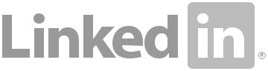

[Contact Michael on LinkedIn](http://www.linkedin.com/in/mdell)

Page 2